Natalie Bahr

6/2/2022

Databases

SQL Hands-On Lesson 2

Part 1

Run the following queries:

1. Write a query to find the first and last name, customer ID and rental ID for customers who have rented a film.

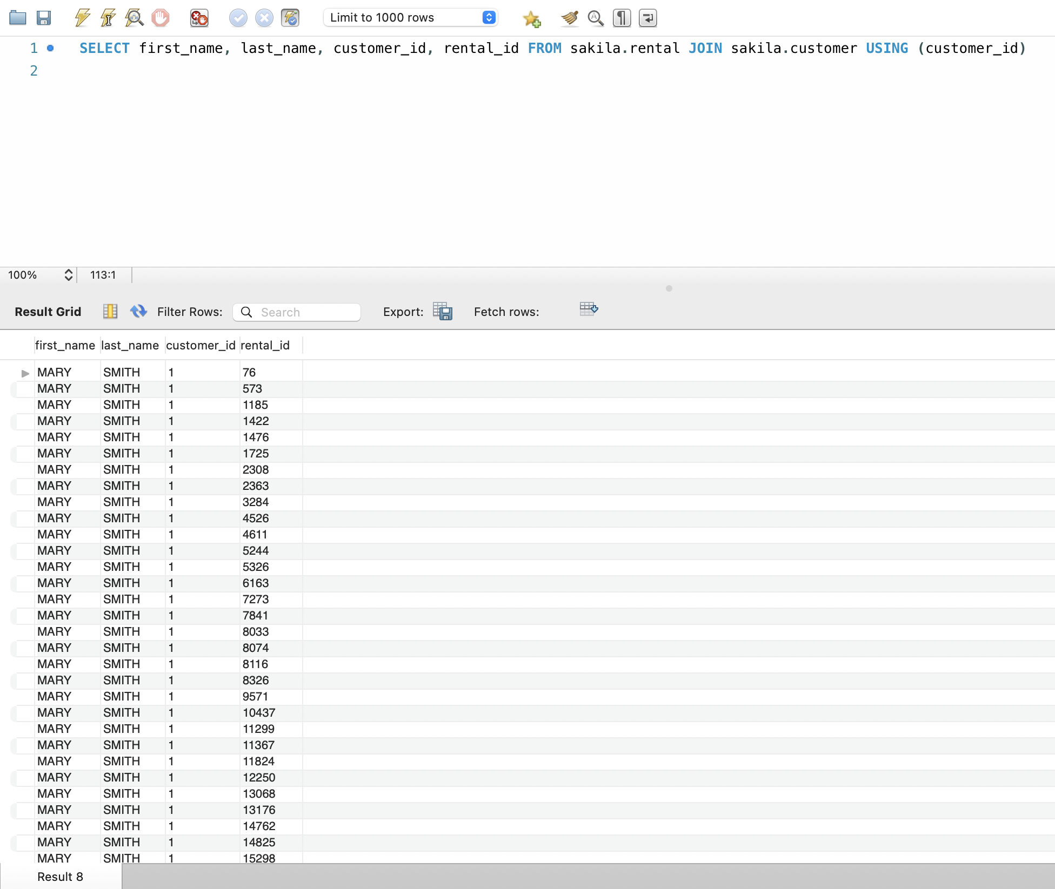

1. Write a query that finds all films with actors that have an actor_id 5.

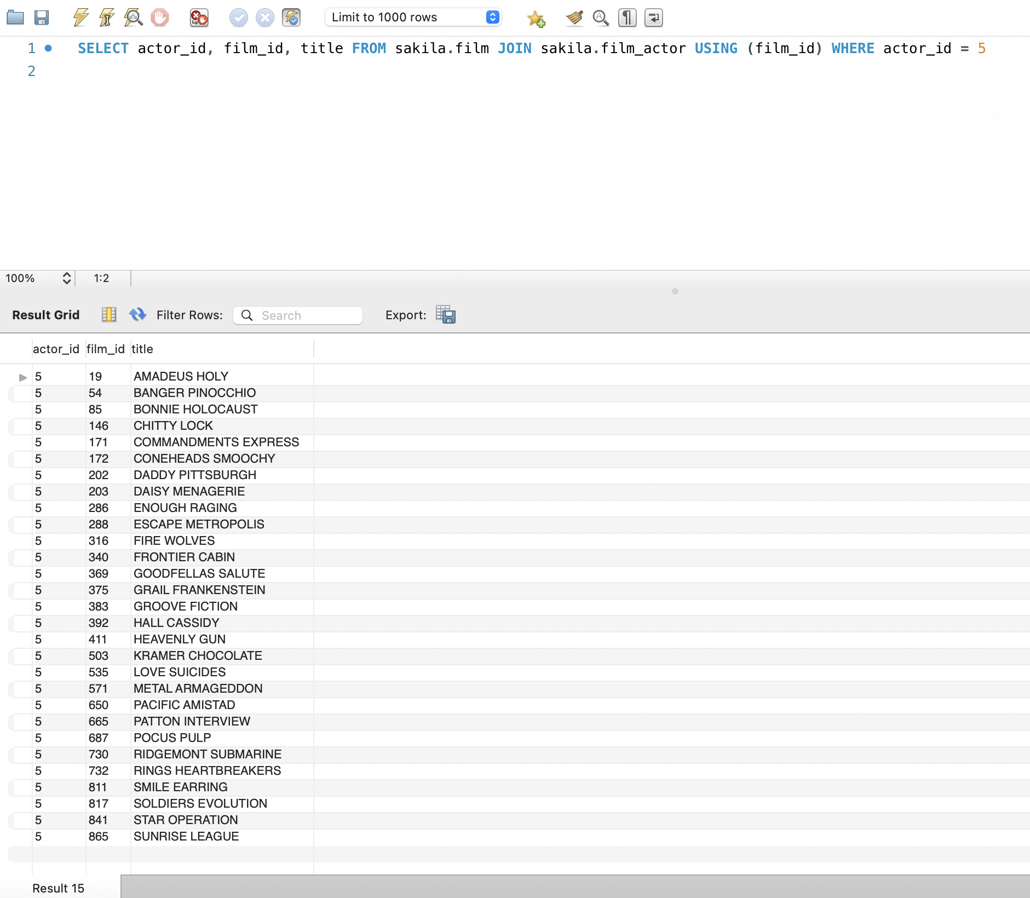

1. Write a query that lists out all information of every film along with the name of the language for each film, even if a language doesn't exist for that film.

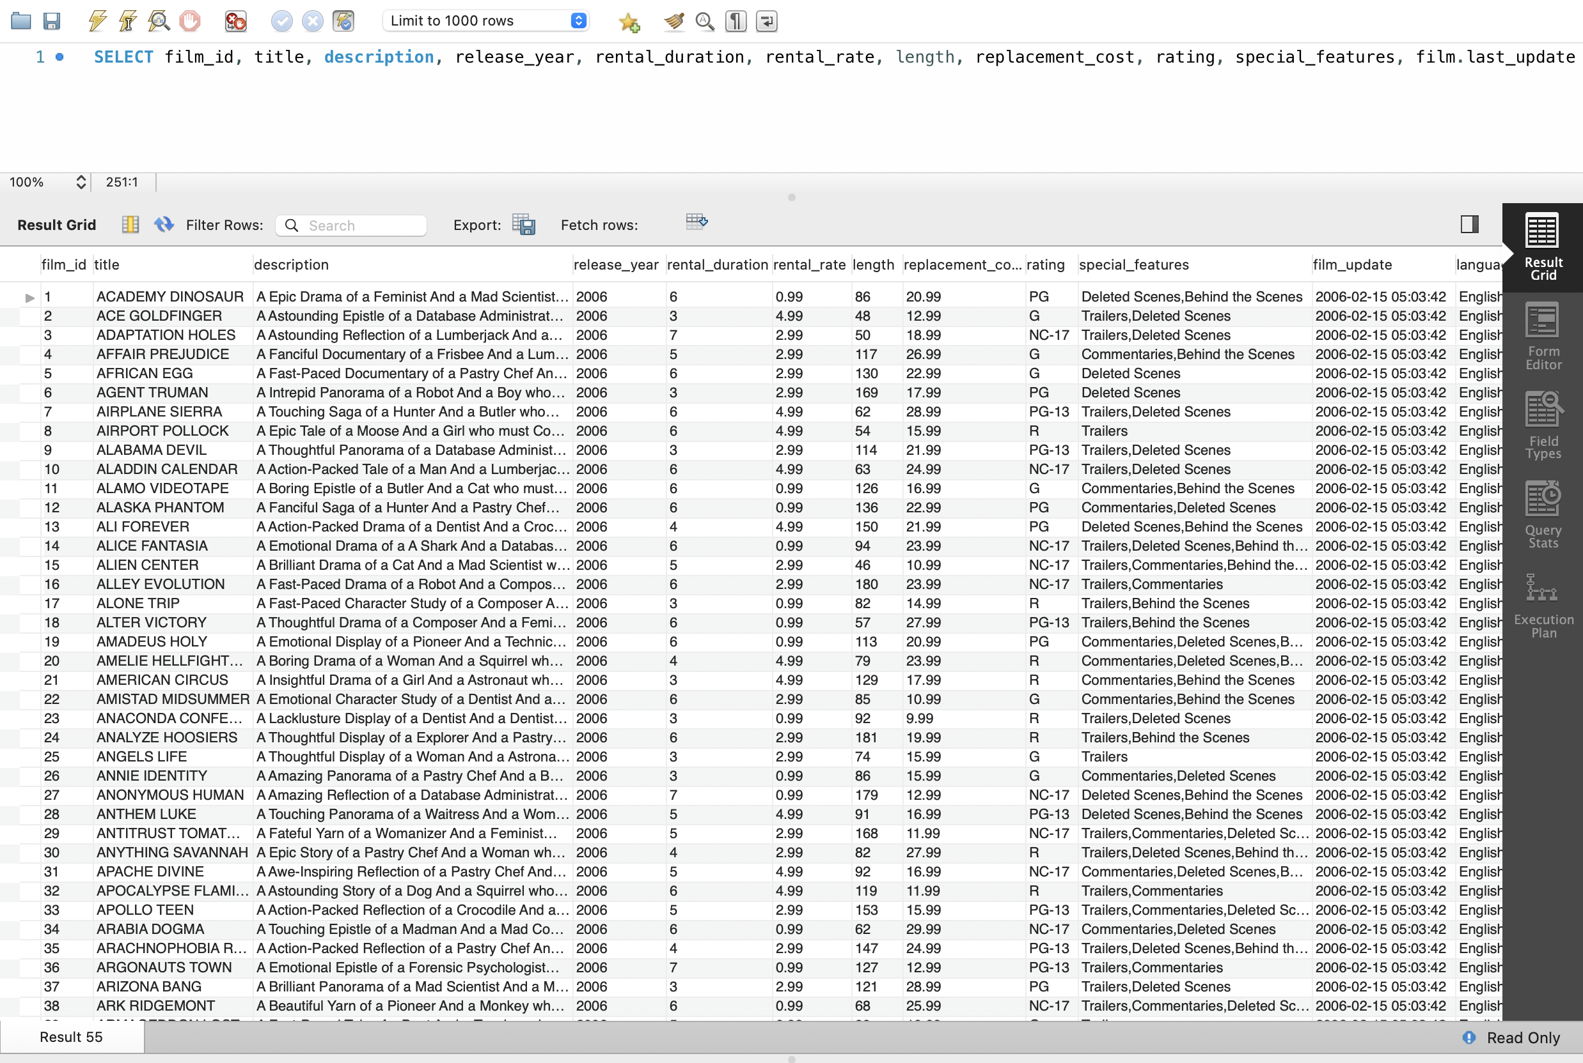

Code continued:



1. Write a query that lists out the title of films and the name of the actors who starred in those films. Additionally, only list films that starred artists whose first names start with a vowel.

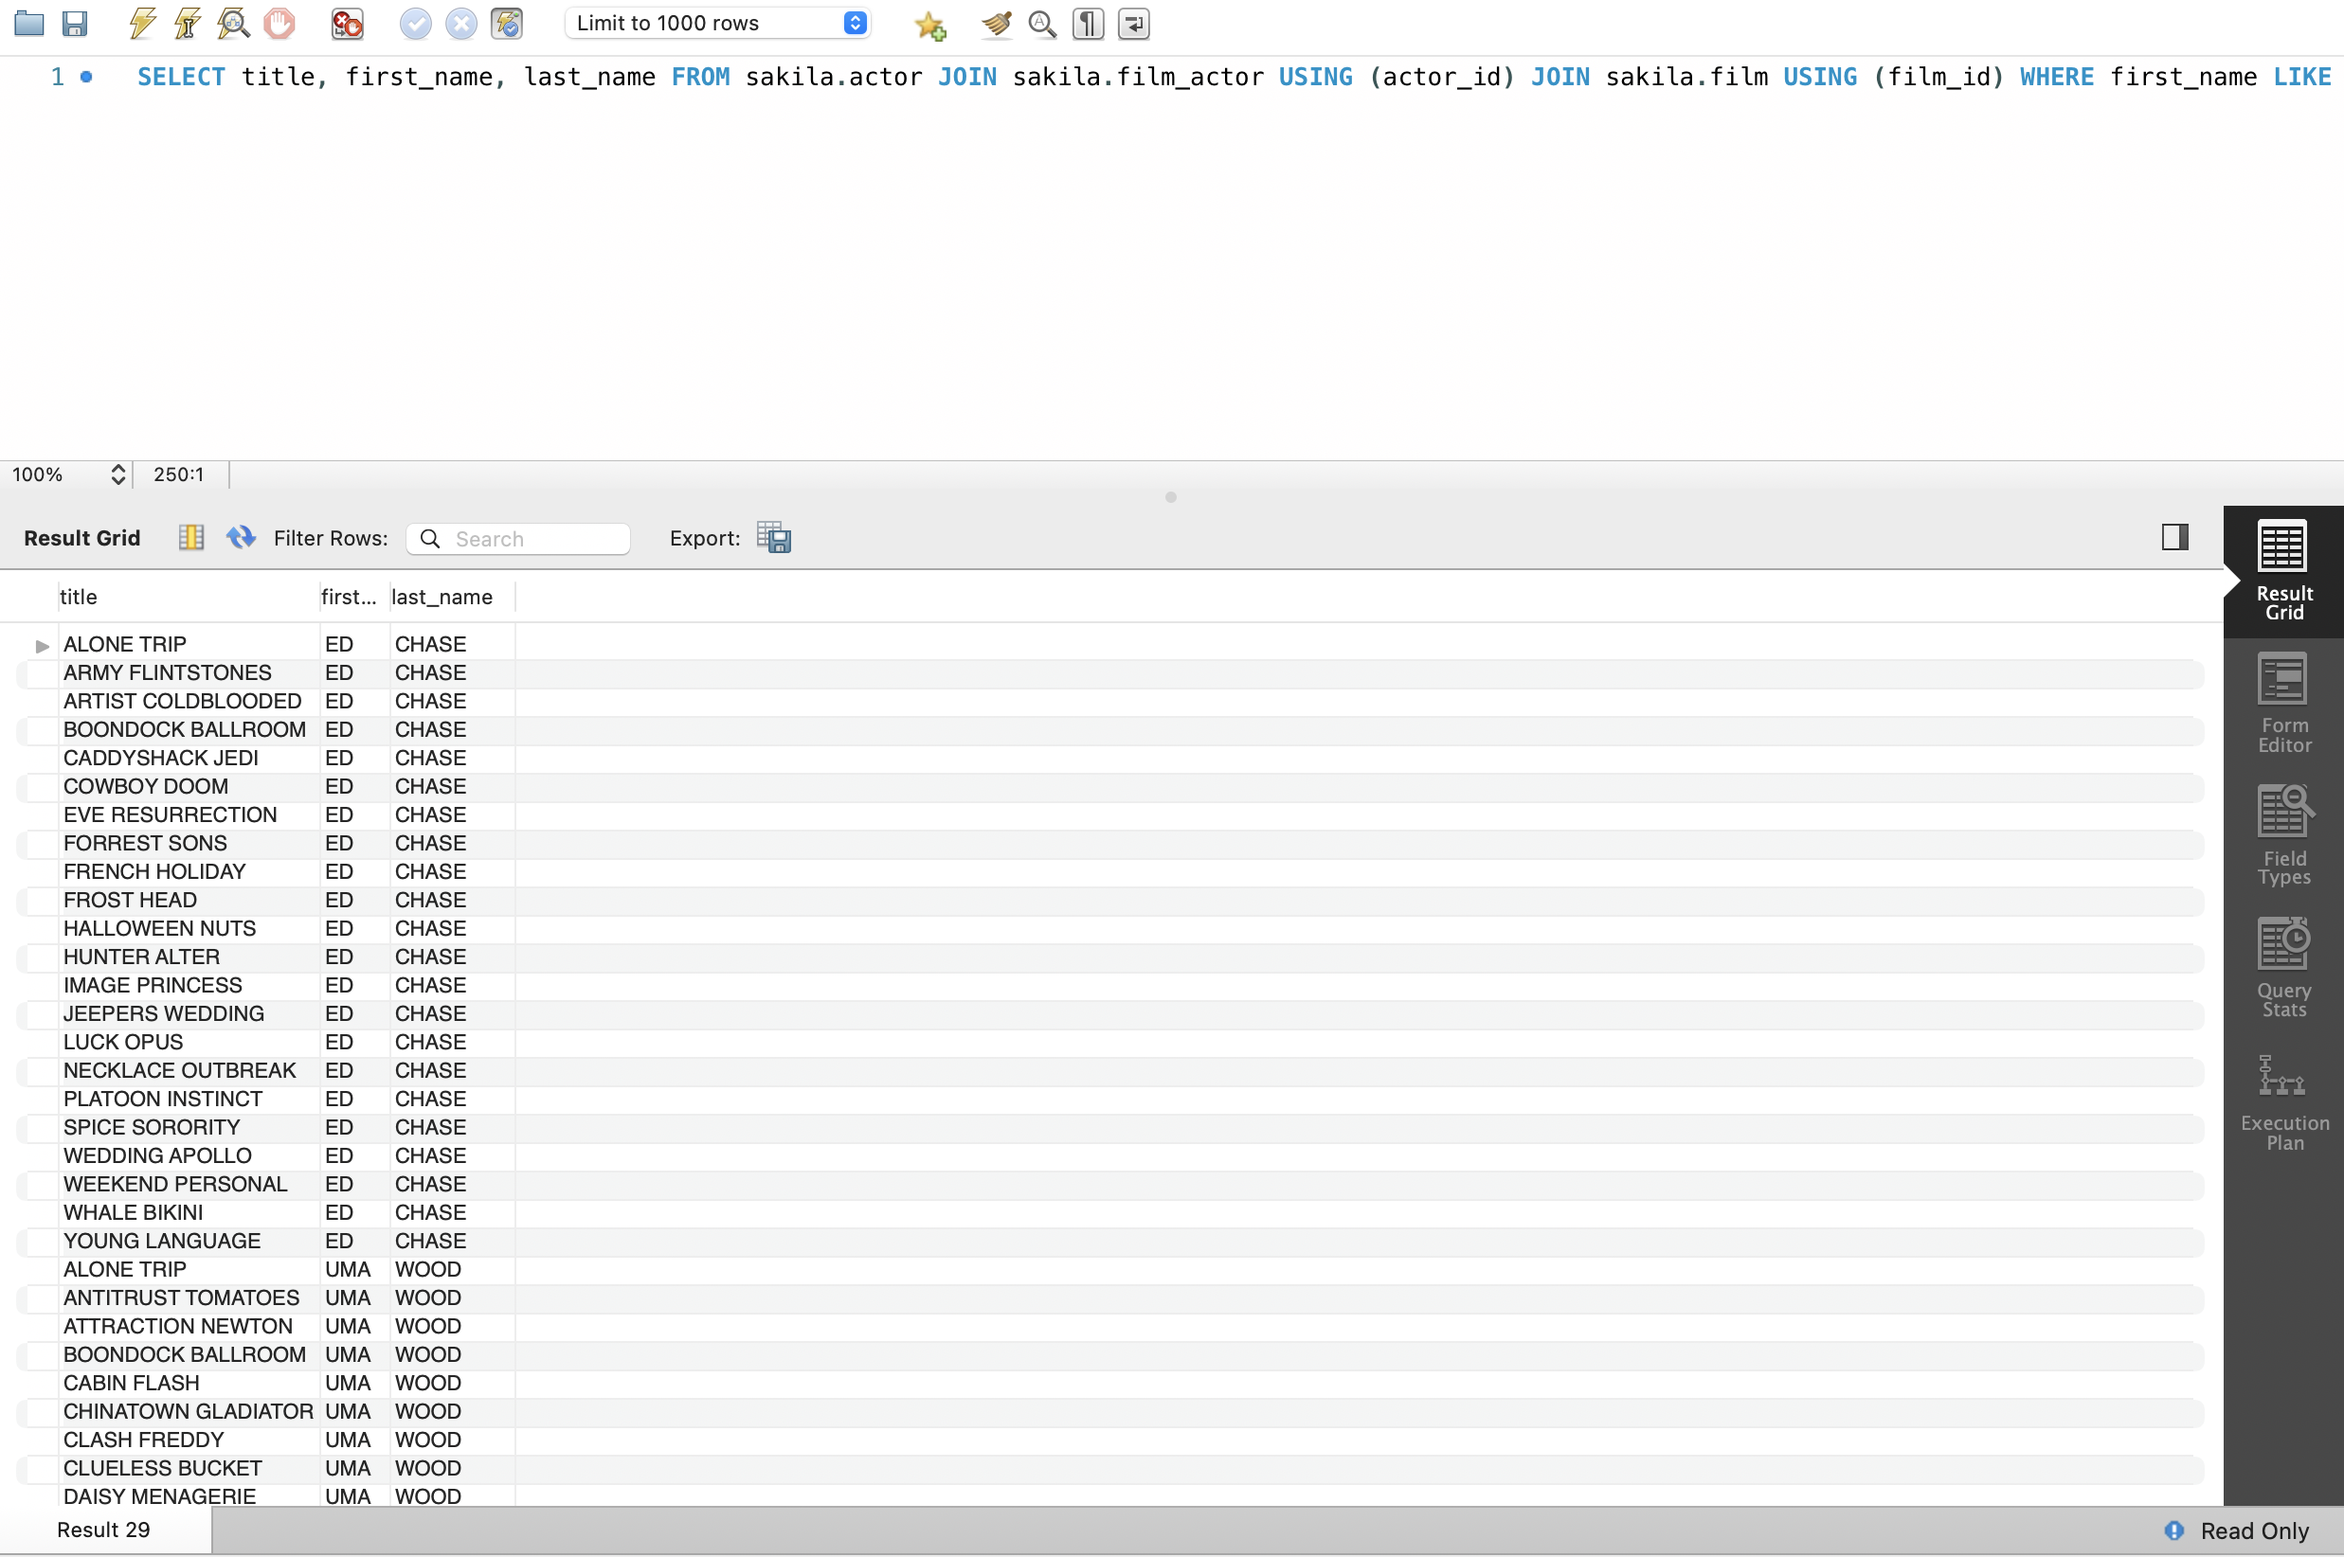

Code continued:



Part 2

Below is a real-life scenario. Please read this scenario and run the appropriate queries needed.

You have just been hired as a Data Analyst for a company that rents films to customers. They would like an inventory list of films that were rented for more than $4.99.

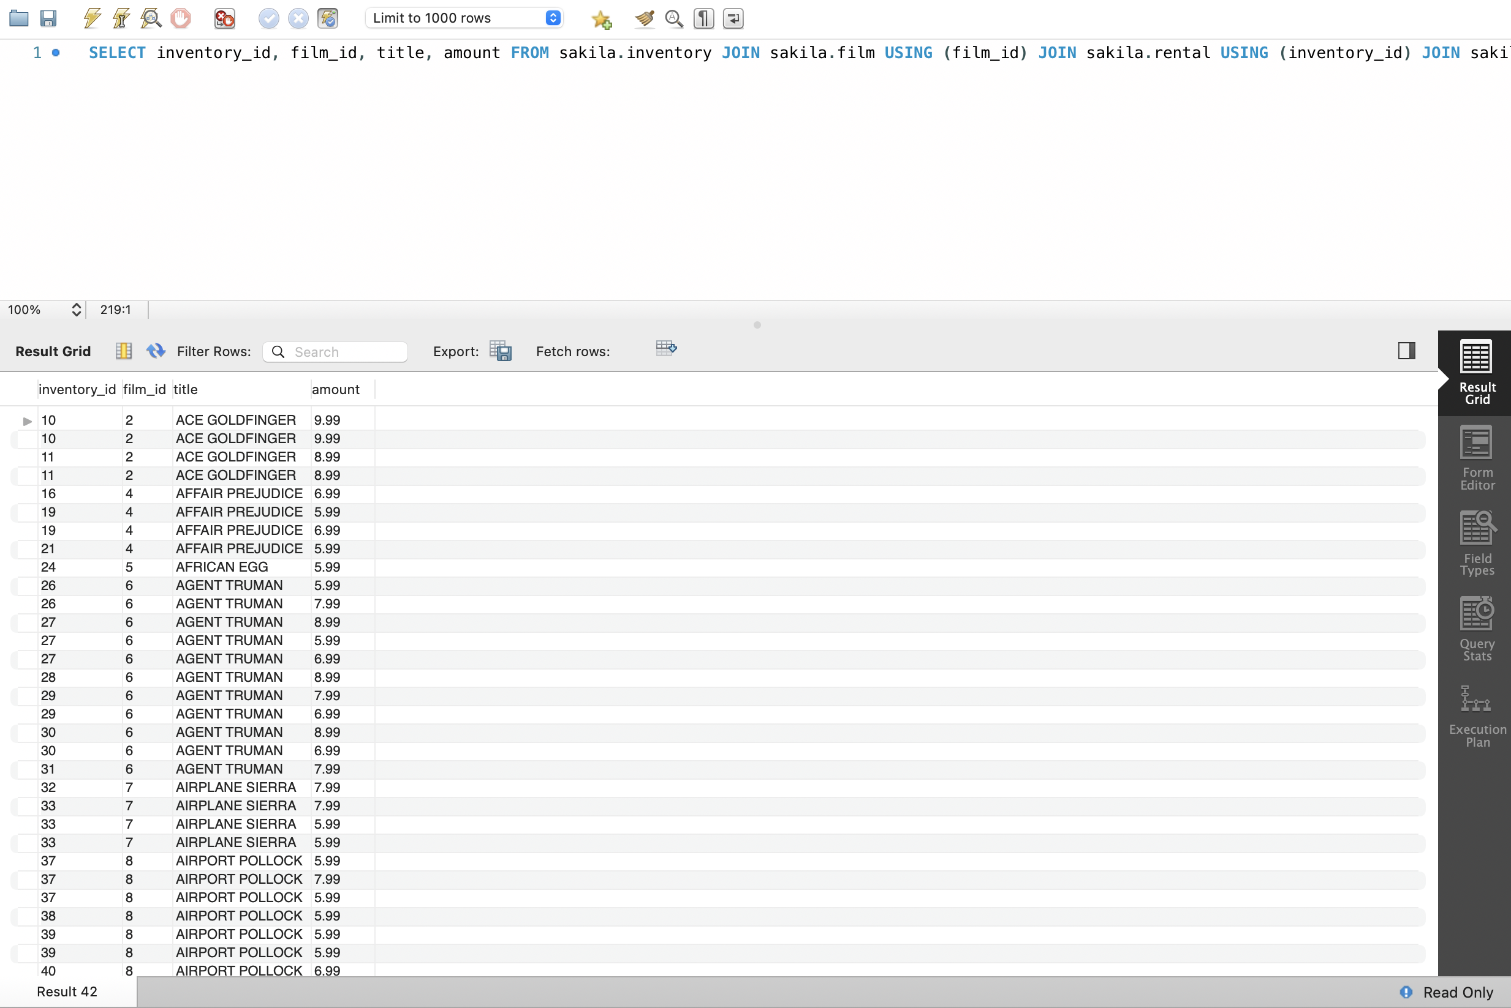

Code continued:

